Section 1: Case Summary

Scenario Title: | Vital Signs Absent (VSA) Megacode
Keywords: | Resuscitation, CPR, Cardiac, RCDP
Brief Description of Case: | A 54-year-old male police officer presents to the ED complaining of chest pain for two hours that started during his weekend hockey game. He is feeling dizzy and short of breath upon presentation. He will have a VT arrest as he is placed on the monitor. He will require two shocks and rounds of CPR before he has ROSC. He will then lose his pulse again while the team is trying to initiate post-arrest care; This will happen several times. Finally, the team will maintain ROSC. An ECG will show a STEMI and the team will need to call for emergent PCI.

Goals and Objectives
Educational Goal: | To provide learners with the opportunity to manage a prolonged resuscitation that requires strong resource allocation skills.
Objectives:  (Medical and CRM) | - Provide quality ACLS care, including:  - Expedient defibrillation for a shockable rhythm  - Appropriate use of ACLS medications  - Use of ETCO2 to guide resuscitation  - Minimizing pulse checks  - 30:2 ratio of compressions to breaths prior to intubation  - Initiate appropriate post-arrest care, including PCI.  - Communicate clearly and lead team through a lengthy resuscitation.  - Recognize compression fatigue in team members and find ways to engage or relieve fatigued members
EPAs Assessed:

Learners, Setting and Personnel
Target Learners: | ☒ Junior Learners |  | ☐ Senior Learners |  |  | ☐ Staff
 | ☒ Physicians | ☐ Nurses |  | ☐ RTs | ☐ Inter-professional
 | ☐ Other Learners:
Location: | ☒ Sim Lab |  | ☐ In Situ |  |  | ☐ Other:
Recommended Number of Facilitators: | Instructors: 1
 | Sim Actors: 1-2
 | Sim Techs: 1

Scenario Development
Date of Development: | 2015
Scenario Developer(s): | Dr. Cheryl ffrench
Affiliations/Institutions(s): | University of Manitoba
Contact E-mail:
Last Revision Date: | Jan 2023
Revised By: | Dr. Chris Bennett Heyd
Version Number: | 1

Section 2A: Initial Patient Information

- Patient Chart
Patient Name: Richard Green |  |  |  | Age: 54 | Gender: Male | Weight: 80kg
Presenting complaint: Chest pain
Temp: 36.7 | HR: 74 | BP: 105/65 |  | RR: 16 | O₂Sat: 99% | FiO₂: RA
Cap glucose: 6.7 |  |  |  | GCS: 15
Triage note:
Played his usual weekend hockey game about 2 hours ago. Developed chest pain during the hockey game. It got better after he stopped and rested for a bit, but it hasn’t really gone away.

Allergies: none
Past Medical History:  none |  |  | Current Medications:  none

Section 2B: Extra Patient Information

A. Further History
Include any relevant history not included in triage note above. What information will only be given to learners if they ask? Who will provide this information (mannequin’s voice, sim actors, SP, etc.)?

Works as a police officer
No history of chest pain
No previous cardiac testing
Non-smoker
Unknown family history
B. Physical Exam
List any pertinent positive and negative findings
Cardio: Normal heart sound, normal pulses | Neuro: Normal
Resp: Normal | Head & Neck: Normal
Abdo: Normal | MSK/skin: Diaphoresis
Other: None

Section 3: Technical Requirements/Room Vision

A. Patient
☒ Mannequin: Adult
☐ Standardized Patient
☐ Task Trainer
☐ Hybrid
B. Special Equipment Required
Crash cart
CPR board
Airway cart

C. Required Medications
Crash cart/ACLS medications
RSI medications

D. Moulage
Diaphoresis (optional)

E. Monitors at Case Onset
☐ Patient on monitor with vitals displayed
☒ Patient not yet on monitor
F. Patient Reactions and Exam
Include any relevant physical exam findings that require mannequin programming or cues from patient
(e.g. – abnormal breath sounds, moaning when RUQ palpated, etc.) May be helpful to frame in ABCDE format.

Feels lightheaded on arrival
Chest pain (heaviness) x2 hours. Retrosternal, radiates to L arm
Feels SOB from walking into department
Mild nausea

Section 4: Sim Actor and Standardized Patients

Sim Actor and Standardized Patient Roles and Scripts
Role | Description of role, expected behavior, and key moments to intervene/prompt learners. Include any script required (including conveying patient information if patient is unable)
Bedside RN(s) | Helpful and skilled  May use multiple nurses for: medications, charting, CPR
Resp therapist  (optional) | Helpful and skilled  For airway management during the resuscitation

Section 5: Scenario Progression

Scenario States, Modifiers and Triggers
Patient State/Vitals | Patient Status | Learner Actions, Modifiers & Triggers to Move to Next State |  | Facilitator Notes
1. Baseline State  Rhythm: Sinus  HR: 74/min  BP: 100/60  RR: 12/min  O₂Sat: 96% RA  T: 36.7 ºC  GCS: 15 | Alert.  Diaphoretic.  Complaining of increased CP, SOB, dizzy. | Expected Learner Actions  IV, O2, monitors  ECG (not given)  Cardiac blood work  History and Physical  ASA 160mg PO chew  Nitro spray | Modifiers  Changes to patient condition based on learner actions  Nitro spray BP 80/40  Triggers  For progression to next state  - 2min 2. VT arrest
2. VT arrest  Rhythm: VT  HR: 180  BP: undetectable  O₂Sat: 74%  ETCO₂: 10 | Patient unconscious and pulseless. | Expected Learner Actions  Immediate defibrillation  High quality CPR  Confirm IV access  Initiate capnography  Compressions:BVM at 30:2  Prepare advanced airway | Modifiers  - 1st shock stays in VT  - Quality CPR: ETCO₂ 16  - Poor CPR: ETCO₂ 8  Triggers  - 2nd shock 3. Brief ROSC | Consider ETT or LMA for airway management  Do not give epi or amio before 2nd shock per ACLS
3.Brief ROSC  Rhythm: Junctional  HR: 55  BP: 85/45  O₂Sat: 95%  ETCO₂: 40 | Patient opens eyes to voice. | Expected Learner Actions  Recheck vital signs  Ask for ECG (not given)  Fluid bolus  Norepi or epi infusion  Consider amiodarone | Modifiers  Triggers  - 1 min into state 1st time 4. VF arrest  - 1 min into state 2nd time 5. PEA arrest
4. VF arrest  Rhythm: VF  HR:180  BP: undetectable  O₂Sat: 68%  ETCO₂: 10 | Patient unconscious and pulseless. | Expected Learner Actions  Immediate defibrillation  High quality CPR  Epinephrine 1amp q3min  Amiodarone 300mg  Advanced airway  Monitor capnography | Modifiers  - 1st shock stays in VF  - Quality CPR: ETCO₂ 16  - Poor CPR: ETCO₂ 8  Triggers  - 2nd shock 3. Brief ROSC | Consider ETT or LMA for airway management
5. PEA arrest  Rhythm: slow PEA  HR: 20  BP: undetectable  O₂Sat: 68%  ETCO₂: 10 | Patient unconscious and pulseless. | Expected Learner Actions  High quality CPR  Epinephrine 1amp q3min  Consider HCO₃ and CaCl₂  Advanced airway (if not yet)  Monitor capnography | Modifiers  - Quality CPR: ETCO₂ 16  - Poor CPR: ETCO₂ 8  Triggers  - 3 rounds or 15 min 6. ROSC
6. ROSC  Rhythm: Sinus/STEMI  HR: 55  BP: 85/45  O₂Sat: 96%  RR:12 (vented)  ETCO₂: 40 | Patient nonresponsive but has pulse | Expected Learner Actions  ECG  Cap sugar (6.2)  Norepi or epi infusion  OG for clopidogrel/ticagrelor  IV Heparin  Call interventional cardiology  Consider cooling | Modifiers  - Vasopressor started BP 95/65  Triggers  - 20 min or cardiology called End Case

Appendix A: Laboratory Results

None given during case

Appendix B: ECGs, X-rays, Ultrasounds and Pictures

Paste in any auxiliary files required for running the session. Don’t forget to include their source so you can find them later!

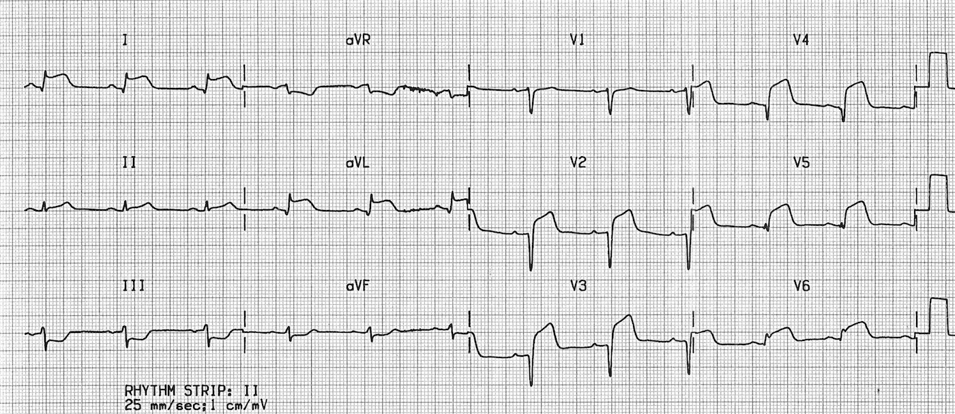
(ECG source: http://cdn.lifeinthefastlane.com/wp-content/uploads/2011/10/anterolateral.jpg)

Appendix C: Facilitator Cheat Sheet & Debriefing Tips

Include key errors to watch for and common challenges with the case. List issues expected to be part of the debriefing discussion. Supplemental information regarding any relevant pathophysiology, guidelines, or management information that may be reviewed during debriefing should be provided for facilitators to have as a reference.

Sample Questions for Debriefing
- How did it feel to have your resuscitation intermittently produce ROSC?
- This was a long and frustrating case. Did you consider the fatigue of team members? What was your strategy to address fatigue?
- Were you using ETCO₂ to assess compression quality and ROSC? How is ETCO₂ helpful?
- How and when do you initiate therapeutic hypothermia after a cardiac arrest? When is it contraindicated?

Key Moments
- Recognition of loss of pulse, initiation of ACLS
- Recognition of ROSC and then repeated pulse loss
- Recognition of STEMI and calling cath lab

Consider Using Rapid Cycle Deliberate Practice
- See infographic on the following page
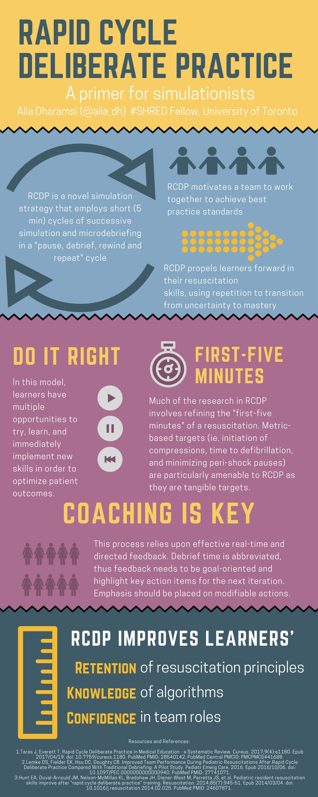
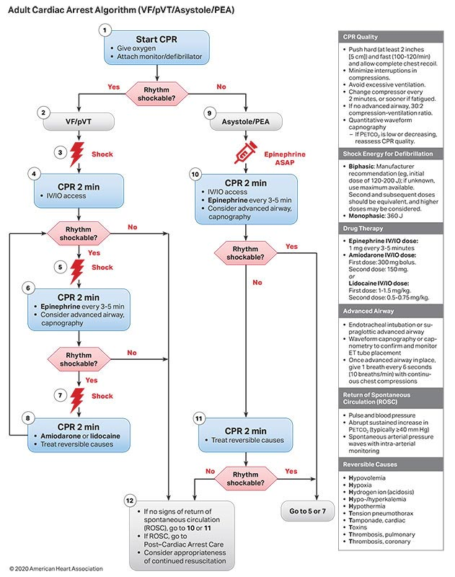

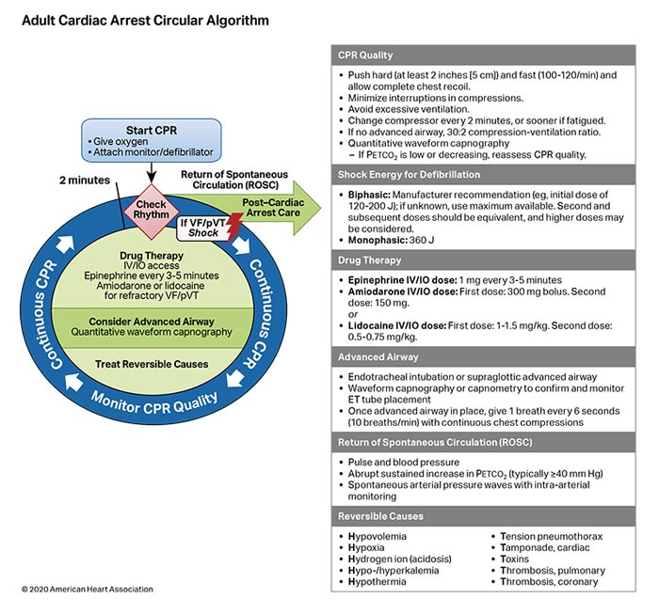

References

1. American Heart Association. 2020. ACLS Algorithms. https://cpr.heart.org/en/resuscitation-science/cpr-and-ecc-guidelines/algorithms

